**Final Project Proposal**

**The US License Plate Recognition**

Xu Liang, Zehua Liu, Hao Lei

**1. Significance**

At present, most parking lots in the United States are not equipped with a license plate recognition system. Large-scale parking lot payment uses the *Get Card for Entering, Return Card for Leaving* mode. In this mode, the car owner needs to keep the parking card or parking ticket properly. If, as already applied in some countries or regions, a license plate recognition device is installed at the entrance of a parking lot, and the time difference between the entering and leaving of the same license plate number will be calculated as the parking time, parking payment can be simpler and more environmentally friendly.

**2. Differences from** **Predecessors’ Works and Why**

We have consulted relevant papers on license plate recognition and tried to find those that can solve the problem of *The US License Plate Recognition (USLPR)*. The predecessors have done a lot of work on the influence of light, angle, clarity, etc., and the related technologies are already mature. But unfortunately, most of the license plates used for recognition in those papers are from China, Japan, Korea, European countries, Japan, Brazil, etc. In those countries, the license plates themselves do not have complicated background patterns. And compared with the US, the data sets of these license plates are much larger, thereby reducing the difficulty of direct character recognition. According to some papers that mentioned the USLPR, Yolo-CNN seems to be a very good choice. Yolo-CNN can quickly identify and locate a variety of objects in the picture. However, the focus of the work of those predecessors is not on the USLPR specifically. They were able to use large sets of existing license plates from other countries as training sets. Since the existing US license plate data is not huge, we decided to avoid using a very limited number of data to train Yolo-CNN.

Therefore, we are trying to use multiple networks with relatively simple structures to replace one powerful network, and decentralize the Plate Detection, State Recognition, Sequence Extraction, Character Recognition processes to reduce the difficulty of implementation of each part and improve the overall stability. If we encounter difficulties in license plate detection, character segmentation, or character recognition in the future, we may reconsider using Yolo-CNN.

**3. Overview**

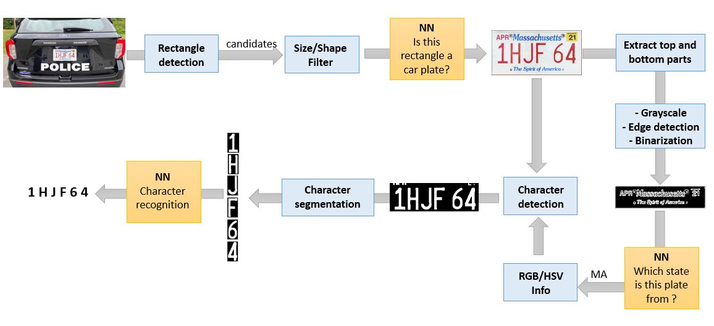

**4. Technologies**

Our project contains 5 main parts: Plate Detection, State Recognition, Sequence Extraction, Character Segmentation, and Character Recognition. The flowchart is shown above.

**4.1 Plate Detection**

Plate detection contains the following steps:

1. Use Erosion and Dilation processing to reduce noise.

2. Use Canny edge detection to find all contours on the image.

3. Filtering. Filter out unqualified contours based on the perimeter and area of them, find the minimum circumscribed rectangles for the qualified contours, and filter out unqualified rectangles based on the height and width.

4. Input all rectangles left into CNN to identify whether it is a real license plate.

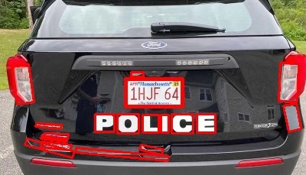 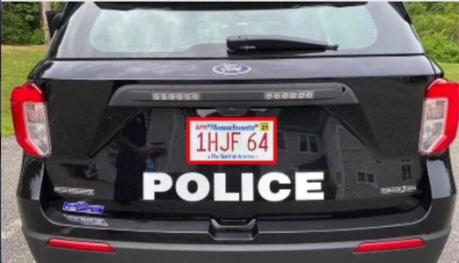

Preliminary rectangle detection and result after filtering

**4.2 State Recognition**

We plan to use CNN for state recognition of license plates. The license plate of a state has very significant characteristics of this state in the place other than the sequence, and the characteristics of the license plate of the same generation are stable.

The upper and lower parts of the license plate are cropped to obtain sufficient state features, and the image is sequentially grayed, edge detected, and binarized. Since the result is a binarized picture, the pressure they put on the state recognition CNN will be very limited. The following figure shows the state features extraction results of different license plates in the three states of MA, MS, and MD:

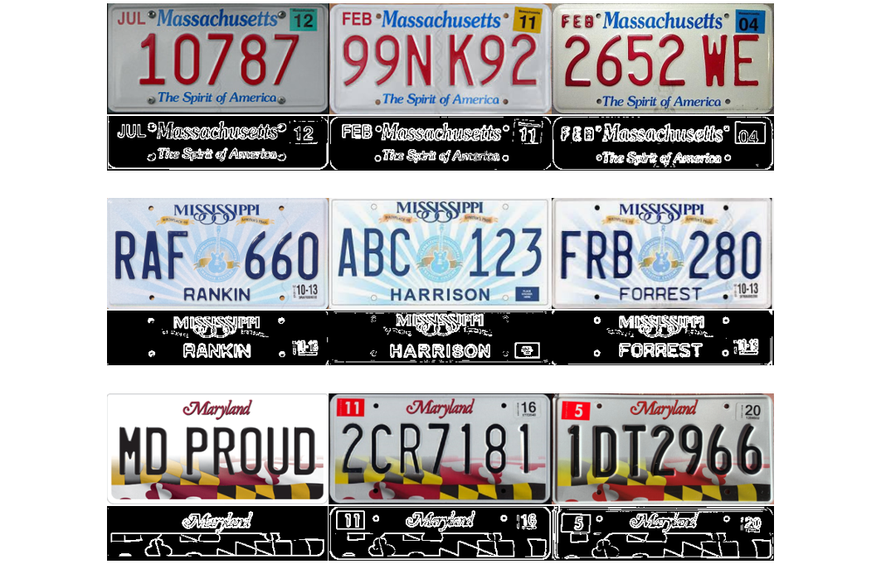

The significances of state recognition are: 1. The sequence color of the same generation of license plates in the same state is relatively stable. Given the state of the license plate, the corresponding RGB or HSV range can be used to extract the sequence rather accurately, effectively avoiding the interference of those patterns around the sequence; 2. Even if the sequence cannot be identified, the given state can at least narrow the scope, which has a certain significance in the field of criminal tracking.

**4.3 Sequence Extraction**

After knowing the state of the license plate, we will obtain the corresponding RGB/HSV range, using which to extract the sequence. However, if simply using this, the sequence extraction image may not be plumped. We plan to use dilation/erosion to enhance the pattern. Since the sequence of the license plates of each state is basically in the middle position, we can appropriately cut off the upper and lower parts of the license plate.

In the actual situation, due to the difference between the new and old license plates and the different illumination, the color or brightness of the sequence might vary accordingly. Properly widening the RGB/HSV range can get good results, as shown in the figure below.

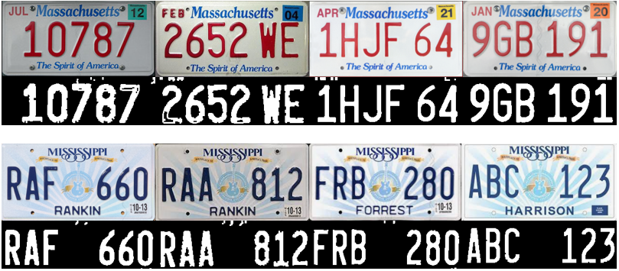

**4.4 Character Segmentation**

Character segmentation is based on connected domains. After Morphological processing, each character becomes a whole block. Then, use the edge detection to obtain the contour of each character. After that, find the minimum circumscribed rectangles to identify each character. The result is shown below.



The input of a character segmentation case

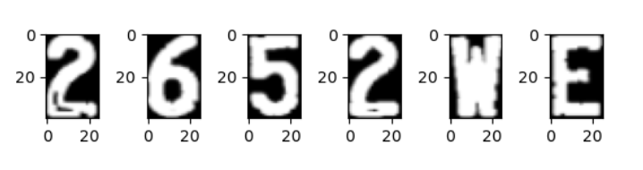

The output of the above case

**4.5 Character Recognition**

The existing supporting technology for this part is already mature. Below is the CNN model we might be intended to use.

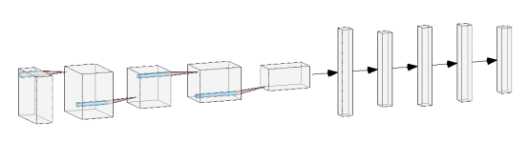

**5. Data Set**

For the last part, Character Recognition, the dataset is easy to access.